**SE185: Problem Solving in Software Engineering**

**Quiz #2 (100 points)**

|  |  |
| --- | --- |
| Name: Miles Nichols | Name: |

Answer the following questions and make a pdf file that includes the **source code, sample inputs, and outputs**. You must submit the **pdf file and all of the .c files** on Canvas for full credit. Do not forget to add your group partner name on the pdf file and the source codes.

1. **(50 points)** Write a complete C program that scans in your first and last name, major, year in college (ex. Freshman, sophomore, etc.), and graduation year. Then, print the output in following format:

**Inputs and outputs format**

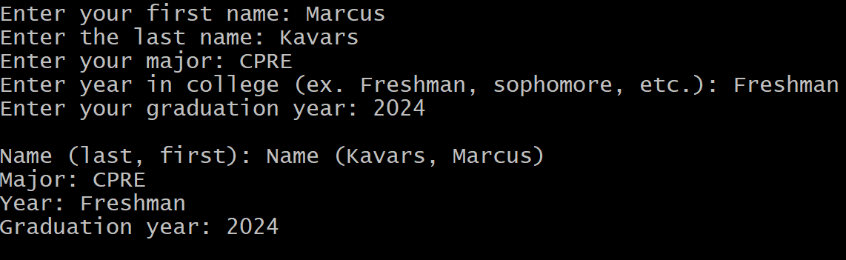

1. **(50 points)** Write a complete c program that ask the user to enter the drivenMiles, milesPerGallon, dollarsPerGallon, and print the dollar cost to drive those miles.

* Your program must use an user defined function named **DrivingCost** with input parameters **drivenMiles**, **milesPerGallon**, **and dollarsPerGallon**, that **returns the dollar cost** to drive those miles.

**Inputs and outputs format:**



